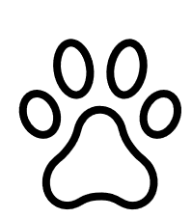
Dog Rules

Well behaved dogs may stay at The Mill. We ask that dogs and their owners follow a few simple rules while they are staying:
- Dogs are not allowed in The Mill except by prior arrangement.

- Dogs are not permitted in bedrooms or on any furniture – please bring your dog’s bed and towel (Mill towels must not be used for dogs).

- Dogs must not be left unattended in The Mill unless left in the bootroom or in a dog cage
- If you are away from The Mill, please do not leave your dog in the bootroom for more than a couple of hours.

- Dogs must be “house trained”; if there is an “accident” please clear it up immediately and thoroughly. If there is a stain, guests must inform the Watsons.
- Guests are asked to clean up after their dogs, outside of the property. Scoops are provided and the debris can be thrown into the bushes, which we shall show you (they are away from the house and too thick for children to crawl under). Please do a thorough check on departure of dog messes. Dogs are not allowed on the bottom outside terrace downstairs.

- Dogs must always be properly controlled and supervised, especially in the surrounding fields with sheep & cattle. There is a fenced off area in your garden / woodlands above for lots of roaming and playing
- You agree to accept full responsibility for any damage or staining caused by your dog during your stay, and you agree to pay the cost of any repair or additional cleaning requirements
- When walking your dog please close all gates behind you.

